**The AWRCC Trust Education Program**

PROFESSIONAL DEVELOPMENT APPLICATION FORM (short form version)

CNSA / ISNCC Congress 2025

The AWRCC Trust Education Program is a program managed by theAWRCC Cancer Services Education Committee, aimed at improving the skill, capacity and scope of practice of staff that work in the AWRCC, and staff that treat and support AWRCC patients across the health service and in the community.

Before completing and submitting your application for professional development, please ensure that you have read and understood the AWRCC Trust Education Professional Development Applicant Guidelines.

Applicant Information

|  |  |
| --- | --- |
| Title: (please circle) | Mr / Mrs / Ms / Miss / Dr / Other |
| First name: |  |
| Surname: |  |
| Mobile No.: |  |
| Email Address: |  |
| Are you Aboriginal or Torres Strait Islander origin (please circle): Yes / No / Prefer not to answer | |
| Employed Position: |  |
| Duration in Position: |  |
| Employer: |  |
| Manager Name: |  |

**Manager endorsement for this professional development application**

**________________________________________ ___________________________________  Study Leave Approved**

Signature Date

Proposed Professional Development

|  |  |
| --- | --- |
| Organisation or Training Provider: | CNSA/ISNCC Congress 2025 - Adelaide |
| Link | [CNSA & ICCN 2025 Congress](https://www.cnsacongress.com.au/) |
| Training/Course Date: | June 18 to 21 2025 |
| Total Awarded Funding: | Up to $1400 |

**How do you anticipate that completing this training/course will bring positive benefits to yourself, your colleagues and/or your patients (specific to your role)?**

Please type here

**Are you applying (or have you applied) for other sources of funding in relation to this activity?**

**⬜** Yes

⬜ No

**Have you previously received funding from the AWRCC Trust Education Program?**

**⬜** Yes (please provide details below)

**⬜** No

Please type here

**Acceptance Form (All Applicants to complete and sign the section below)**

**The AWRCC Cancer Services Education Committee requires that individuals accepting financial support for professional development are committed to the following:**

1. Provision of evidence stating professional development and any associated costs for which this application is for.
2. Full disclosure of any other funding received in part or in full for any costs related to this activity.
3. Provision of evidence of completion (e.g., attendance certificate).
4. Where applicable, provision of results for training/courses undertaken on understanding that only passed units will be paid for, failed units are at the cost of the student.
5. Confirmation of willingness to participate in media to promote the program and thank those who donate to the AWRCC Trust Fund. This includes providing a photograph of the funding recipient at the course/training/event for possible inclusion on social media and/or Trust Fund Communications.
6. That signing this form indicates a commitment to continue working at the AWRCC or in a role that supports AWRCC patients after completing the professional development for a minimum period of three years, and an understanding that should employment cease before the minimum period a reimbursement of 30% of total awarded course fees will be required;

*Continued next page*

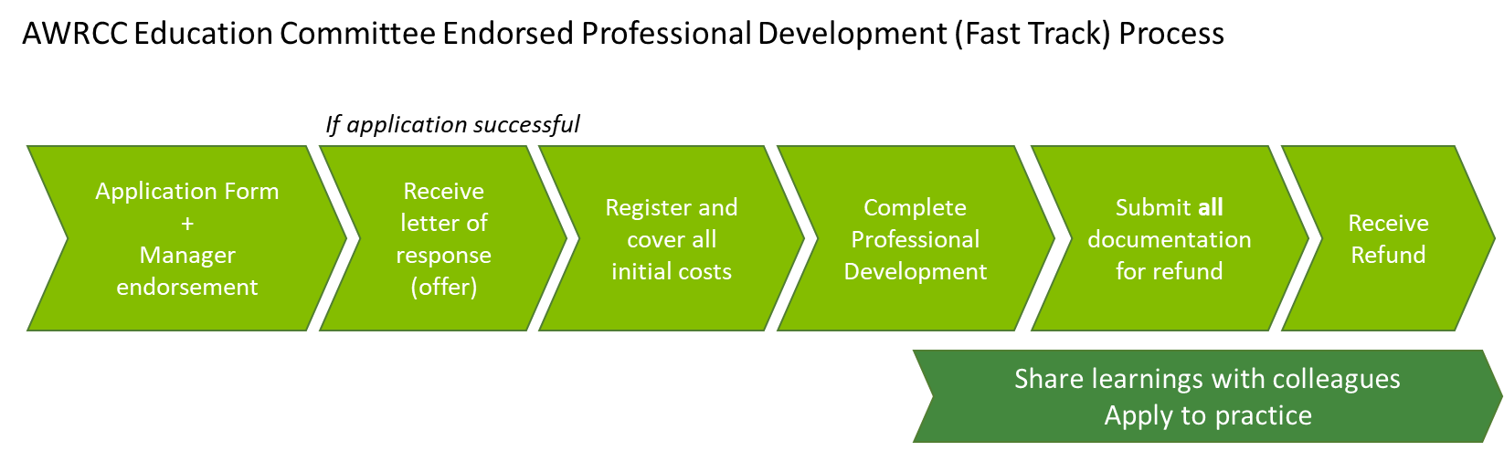

* Applicant completes and submits application (including manager’s endorsement).
* Upon confirmation of a successful application, the applicant will receive an offer letter notifying them of the outcome and a conditional commitment to award up to a specified amount of funds to the applicant.
* Applicant accepts offer, registers, and pays for the professional development and associated costs.
* Applicant provides receipts of all costs specified in a), bank details and attendance certificate in a single communication to [AWRCC@awh.org.au](mailto:AWRCC@awh.org.au) for reimbursement.
* The amount the applicant is eligible for will be reimbursed once all required evidence and information has been received. Please allow up to 4 weeks for processing.
* Applicant agrees to provide a photo representing them at the funded activity and feedback for grant reporting requirements to the AWRCC Trust Fund Inc.
* Applicant agrees to prepare and present a brief presentation on their learning experience if requested.
* If the applicants fail to attend the full course/training/event or receives other funds for items listed in a), the applicant will be required to reimburse the AWRCC Trust Education Program. Extenuating circumstances may be considered by the committee.

**I accept the above terms.**

**_______________________________________ ____________________________________________ __________________________**Signature Full Name Date

**The completed application form and Acceptance form are be submitted to:**

The Chairperson

TheAWRCC Cancer Services Education Committee

Email: [AWRCC@awh.org.au](mailto:AWRCC@awh.org.au)

The AWRCC Trust Education Program is generously supported by the AWRCC Trust Fund Inc.

That raise funds to support cancer services in the Albury Wodonga region to provide quality care to patients and families. Through the help of their fundraising committee to the volunteers and that put in their time and effort to raise funding within the community we are extremely grateful for the funding for Education within AWRCC.