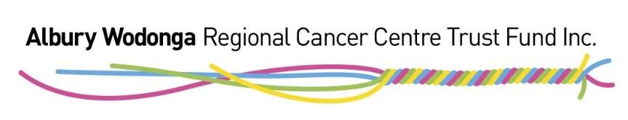
REGISTRATION FORM

FOR COMMUNITY ORGANISATIONS OR INDIVIDUALS
WISHING TO RAISE FUNDS FOR THE
ALBURY WODONGA REGIONAL CANCER CENTRE TRUST FUND

The Albury Wodonga Regional Cancer Centre Trust Fund receives many enquiries from community groups and individuals wishing to run an event or plan an initiative to help raise funds for the Cancer Centre. These requests are very welcome and much appreciated – thank you.

There is a requirement for any fundraising event or initiative to pre-register with the
Trust Fund by completing the below form. Please also make sure you have read and understood the Albury Wodonga Regional Cancer Centre Fundraising Event Guidelines before completing this registration form.

Thank you for your consideration and support.

- Name of organisation or community group conducting the event/initiative:

- Address of organisation or community group:

- Details of key contact person:

Name

Phone Email

- Name of event/ initiative:

- Brief description of the event/initiative:

- Date and time of event (if known):

- Venue and/or address of event (if known):

- The Albury Wodonga Regional Cancer Centre Trust Fund is the sole beneficiary of monies raised from this event/initiative:

YES / NO

If no, please list other beneficiaries:

- The net proceeds (income less expenses) of the event/initiative will be donated to the Albury Wodonga Regional Cancer Centre Trust Fund:

YES / NO

If no, please state what amount or percentage of funds raised will go to the Trust Fund:

- Event disclaimer:

Please tick the boxes below to indicate the fundraiser agrees to the following terms and conditions:

- I have read and understood the Albury Wodonga Regional Cancer Centre Trust Fund Fundraising Event Guidelines
- Potential donors will only be directed to the Trust Fund’s official website (www.awcancertrust.org.au) for online and electronic donations, rather than requesting donations go to an alternative bank account and be then passed on to the Trust Fund
- Financial liability, public liability and public safety are the total responsibility of the fundraiser. The Trust Fund will not be liable for any expenses incurred in organising or promoting the event.
- The fundraiser will adhere to all conditions outlined in section 6.4 of the Fundraising Event Guidelines in relation to the use of the Trust Fund’s brand and logo
- The fundraiser agrees to forward samples of all promotional materials and correspondence such as media releases in relation to the event to the Trust Fund for approval before publishing, promoting or distributing materials.

- Any further comments or information about the event:

Key contact person signature: .......………………………………………………… Date: …………

Please return to:
Jane Evans
Fundraising, Marketing and Events Manager
Albury Wodonga Regional Cancer Centre Trust Fund
Office based at Murray Valley Private Hospital Wodonga
PO Box 479, Albury NSW 2640
Phone: 02 6056 7023
Email: info@awcancertrust.org.au
Website: www.awcancertrust.org.au
Office days: Monday, Wednesday and every 2nd Friday

